Pyramid Model Framework Workgroup Notes
September 21, 2023
Join Zoom Meeting
https://us02web.zoom.us/j/85731469328
Meeting ID: 857 3146 9328
One tap mobile
+16468769923,85731469328# US (New York)
+16469313860, 85731469328# US

Workgroup Members Present: Cori Hill, Ann Brager, Jill Yates, Jaylene Trueblood, April Birchfield, Ariel Chambers, Christy Harrison, Leslie Pakula, Dana Childress, Sarah Moore
Workgroup Members not Present: Deana; Gabrielle will no longer be available to participate. Richard plans to join us in the future.
Review of Last Meeting -Our last meeting was 8/17/23.
State SSIP Updates
- 4-Part SSIP Planning in Action Webinar Series began 9/7/23 with Kyla presenting an overview to the SSIP work. Anne Brager presented on 9/14/23 on our Pyramid Model work and the third session will be this afternoon at 3PM. All sessions are being recorded.
Orientation to our task:
Background
State Identified Measurable Result: Increasing the percentage of infants and toddlers who substantially increase their rate of growth in the area of positive social-emotional skills (including social relationships) by the time they exit early intervention

Objectives to Consider and Current Status:
Broad Improvement Strategy 2: Identify and implement evidence-based service delivery practices to promote positive social-emotional development for all eligible infants and toddlers and provide effective intervention to address delays and concerns:
1. Explore available evidence-based practices to support positive social-emotional development and social relationships (e.g., Pyramid Model, PIWI, FAN, DEC Recommended Practices) in order to identify a core practice that will be implemented statewide
· Completed- Pyramid Model chosen
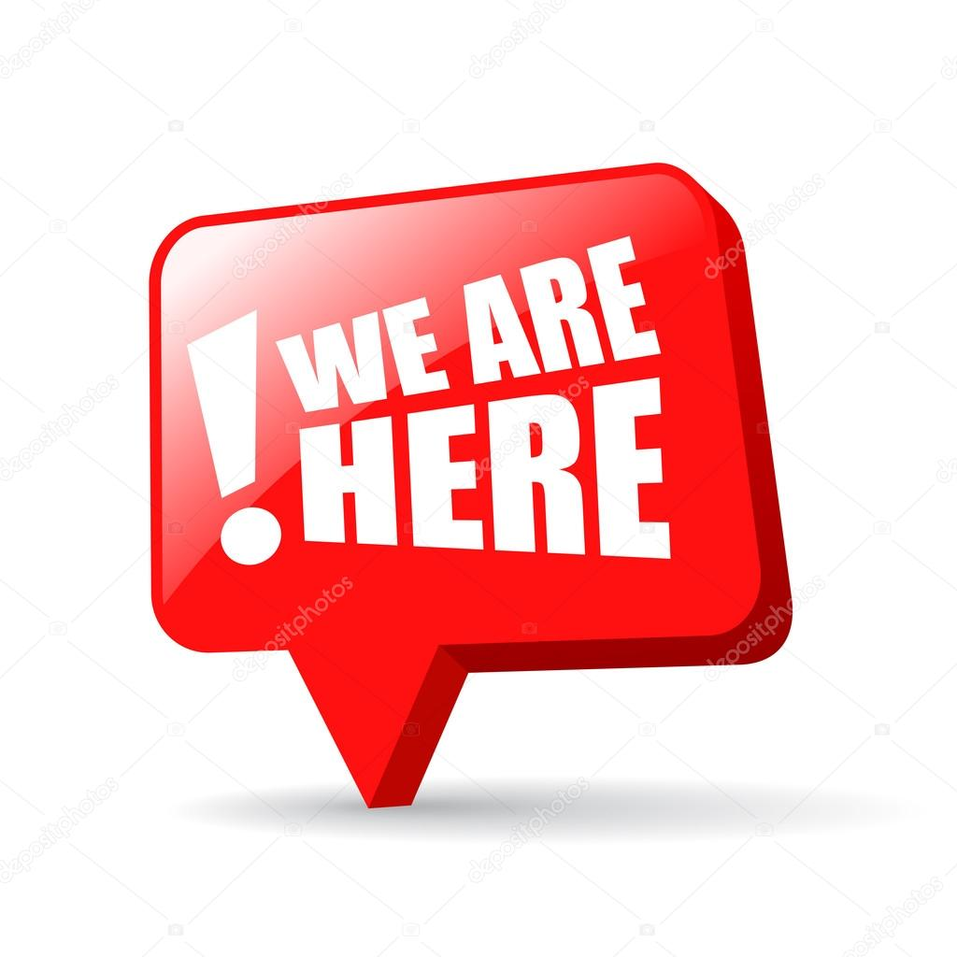2. Once an evidence-based practice is identified for statewide use, develop
an implementation plan including professional development activities and resources needed to support implementation
· Workgroup members are working to familiarize themselves with the Pyramid Model to assist with developing an implementation plan
3. Develop/adapt/adopt and implement a fidelity measure and process for expected service delivery practices
4. Identify and implement additional professional development and/or other supports needed to sustain the use of expected service delivery practices with fidelity.
Discussion and Action Items
Workgroup survey responses and discussion
- Responses will drive our discussion and planning. Responses represent 4 of 6 regions. Widespread in experience (2-38 years).
- Survey responses were analyzed by common themes and will help us determine workgroup tasks.
- Takeaways:
  - Pyramid model has effective workforce as the foundation which promotes the importance of professional development for the field. The model builds on what we already do and adds skills for supporting social skills and emotional regulation. We also need to define “framework” if we use this word.
  - Adults learn best when building on prior knowledge and experience, have time to practice, and reflect and receive feedback. This will be important as we plan. This also connects to the other SSIP workgroup on reflective supervision.
  - This gives the message that you are already doing good practices so the Pyramid work gives you additional tools to build on that. There is not really a step-by-step guide for how to use this; instead, it is a group of resources. It will be important to help practitioners know how to use these resources and how they build on coaching practices.
Pyramid Model Overview video - Most of the group members had not seen the entire video.
- How can we use this video?
  - Anne runs this video in the Part C update every other month but it gets very few hits.
  - Share some scenarios that explain how the model is being implemented at different levels exists
  - Develop a sheet of talking points for group members and supervisors
    - Could also be shared with staff so they know how to talk with providers and reduce misinformation
    - Could create a laminated badge card to attached to your lanyard so you have the talking points with you at all times (like a cheat sheet)
  - Put out simple learning byte/activity that supervisors can use with staff to introduce the pyramid work and use the video - build awareness
    - Roll a learning byte out specifically to LSMs suggesting they review it with their team and provide why we want them to use it
  - Resource Pop-Up - use the video and relate it to VA and how it fits into what we already have in place; include the talking points sheet
  - Elevator Speech - short 2 min videos in a series to share talking points, info about the tiers, etc.
  - Resource library is under development in April’s program - it will have Pyramid Model info that people could easily access to take and use
    - Maybe other programs could have resources readily available for staff to pull when needed (instead of having to remember to go to a website)
    - Could TTAC help programs purchase these resources?
  - Could we seek grants to support these PD opportunities and resources?
    - There is no funding available as of today.
What is a framework?
- Common words in “framework” definition - basic structure, concept
  - It’s not concrete, it’s a concept.
  - A concept is based on evidence (EI experience and research). Philosophy is based on your own personal beliefs.
  - Conceptual structure that helps EIs support children and families with social-emotional and regulation skills using tools that connect to the evidence-base.
- “The Pyramid Model is a framework of evidence-based practices for promoting young children’s healthy social and emotional development.”
- Embeds concepts/ideas from the DEC Recommended Practices and Mission and Key Principles
- See handout of 5 primary principles for Pyramid Model, which include concepts from the evidence-base on which this model is based.
- SSIP work will connect this framework to work beyond this group, such as with the screening and assessment group.
Pair and Share (Anne and April)
Purpose: Help us find resources and good tools using a scenario. Anne and April modeled at today’s meeting sharing: Pyramid Model Resource Library - use filters to make search easier
We switched this up a bit and paired members and assigned a presentation date. See table below and let us know if you or your partner cannot make that date work.
Task: Develop a VERY SHORT vignette (real or made up). It can be with a child and family, childcare provider, staff member/supervisee, etc. Identify 1-2 tools and resources from the Pyramid Model Resource Library that could support your vignette characters. Be prepared to share those resources (have the urls ready to drop in chat) and describe why you chose those resources, how you see them being used, etc. Plan for no more than 15” to share with the full group.
Pair and Share Teams and Presentation Date
10/19/23 | Dana and Christy
11/16/23 | Leslie and Ariel
(December-no meeting) | —---
1/18/24 | Jill and Sarah
2/15/24 | Jaylene and Deana
Next Meeting: 10/19/23. Need to find a new notetaker as Sarah is unavailable. Ariel has agreed to take notes.
DATE (10:30AM-12:00PM) | NOTETAKER
6/15/23 | Deana
7/20/23 | Ariel
8/17/23 | Christy
9/21/23 | Dana
10/19/23 | Ariel
11/16/23 | Jaylene
December 2023 | SKIP-NO MEETING
1/18/24 | Jill
2/15/24 | April

