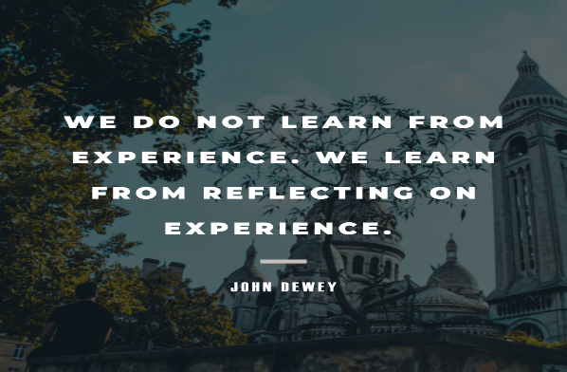

Meeting 1
SSIP Reflective Supervision Workgroup
2/28/2023

Attendees:
Richard Corbett, Erin Austin, Johanna VanDoren-Jackson, April Birchfield, Adele Rohner, Judy Martens, Melinda Whitehurts, Jean Odachowski, Jaylene Trueblood, Tracy Walters, and Lorelei Pisha

Agenda with Notes:
- Welcome and Introductions

- The Why!
Tracy led a discussion on why RS is critical for the promotion of IECMH. The following key points about “The Why!” were emphasized by group members:
- Link between quality of services and the provision of RS to service providers
- Link between RS and retention of personnel
- Economic benefits of RS (in relation to the expense of attrition)
- Importance of a sustainable, systemic, embedded RS framework

- What do we know about RS?
Tracy facilitated conversation about what RS is and looks like. Group members shared experiences with RS, critical components of RS, and resources supporting IECMH providers and supervisors. Key topics included:
- RS leads to improved quality of services
- Importance of family systems focus on the provision of IECMH, rather than viewing the child and caregiver and context as all separate.
- VAIMH’s resources to support providers
- Programs with embedded RS systems

- What would we like to learn about RS?
The group is knowledgeable about IECMH and RS in support of IECMH providers. They would like to learn about effective, sustainable RS system components and how those are being embedded with EI systems - we want to find out what’s working, what the barriers are, and how this could work in VA.

- How might we envision RS in EI systems?
The group participated in a Padlet activity which included listing how members envisioned RS within the EI System. Responses included the following:
- Funding opportunities to support the endorsement and RS process
- Regional and statewide RS support group(s)
- Ongoing training model (not a one and done type model)

Next Steps:
- Our next meeting will be March 28th from 12 - 1pm.
- Please use the Padlet for our group to contribute additional ideas, share resources, etc. between now and our next meeting. You will find additional columns created for resource sharing.
- Please reach out to Tracy with feedback, additional ideas, etc.

